Text Classification Using Machine Learning Algorithms
A Comparative Study on the IMDB Sentiment Dataset
Shri G.S. Institute of Technology and Science, Indore, India

Submitted By:
Vedant Chitlangia | 0801IT231146 | vedantchitlangia2004@gmail.com
Vaibhav Tomar | 0801IT231141 | vaibhev.s.tomar@gmail.com
Group No. GB-6 | Batch B1 | Department of Information Technology | B.Tech 3rd Year
Mentors:
Dr. KK Sharma | Dr. Upendra Singh
Dr. Lalit Purohit | Mr. Akshay Gupta

Abstract
This research offers a comparative comparison of machine learning algorithms for text classification utilized in binary sentiment analysis on the IMDB movie review dataset. The research tackles the difficulty of precisely classifying extensive amounts of unstructured textual data into sentiment categories—positive and negative. Six machine learning models are executed and assessed: Naive Bayes, K-Nearest Neighbor (KNN), Support Vector Machine (Linear SVC), Decision Tree, Random Forest, and an Enhanced Linear SVC with optimized hyperparameters. Pre-processing methods such as tokenization, stop word elimination, lowercasing, noise reduction, and TF-IDF feature extraction with n-gram augmentation are utilized to convert raw text into organized feature vectors. Experimental results indicate that the Enhanced Linear SVC attains the maximum classification accuracy of 89%, succeeded by Linear SVC at 87%, Random Forest at 85%, and Naive Bayes at 84%. Models are assessed with precision, recall, F1 score, and confusion matrices. The results underscore the substantial influence of hyperparameter optimization and n-gram feature engineering on classification efficacy in NLP-based sentiment analysis tasks.
Keywords:
Text Classification, Sentiment Analysis, Machine Learning, TF-IDF, N-gram, Naive Bayes, Support Vector Machine, Improved Linear SVC, Hyperparameter Tuning, Random Forest, IMDB Dataset

1. Introduction
The rapid proliferation of digital textual data — encompassing social media, online reviews, news stories, and scientific literature — has rendered automatic text classification an essential instrument in Natural Language Processing (NLP). Text categorization, the process of assigning predetermined category labels to text documents, allows intelligent systems to derive actionable insights from extensive unstructured content. Sentiment analysis is one of the most extensively researched applications, aiming to categorize text as conveying a positive or negative sentiment.
Conventional rule-based methods for text classification were cumbersome to sustain and lacked generalizability across different domains. The advent of statistical machine learning algorithms in the 1990s and 2000s elevated supervised learning methods, providing scalable, data-driven options. Algorithms including Naive Bayes, Support Vector Machines (SVM), K-Nearest Neighbor (KNN), Decision Trees, and Random Forests have been thoroughly researched and implemented in this field.
This study aims to systematically evaluate the performance of traditional machine learning models using a recognized benchmark sentiment dataset. Notwithstanding progress in deep learning and transformer models, traditional machine learning methods continue to be pertinent for resource-limited settings and applications emphasizing interpretability. This study's principal contributions are: (1) a replicable pipeline for text preprocessing and feature extraction; (2) the application of five classification algorithms utilizing scikit-learn; (3) a thorough comparison assessment employing standard NLP metrics.
This paper is structured as follows: Section 2 offers a literature review of current text classification methods; Section 3 delineates the methodology, encompassing system architecture, flowchart, and algorithm design; Section 4 addresses implementation specifics; Section 5 presents and analyzes the results; Section 6 concludes the paper.

2. Literature Review
Text classification possesses a comprehensive history encompassing rule-based, statistical, and deep learning methodologies. Dwivedi and Arya (2016) examined automatic text classification techniques in information retrieval and determined that supervised learning methods regularly surpass rule-based approaches in terms of scalability. Their survey recognized Naive Bayes and SVM as fundamental techniques for extensive document classification.
Pang, Lee, and Vaithyanathan (2002) pioneered sentiment classification with machine learning approaches, illustrating that SVM with bag-of-words features surpassed human-constructed patterns in detecting movie review polarity. Their research established the IMDB domain as a standard baseline for sentiment analysis. Manning, Raghavan, and Schutze (2010) offered an extensive examination of information retrieval and probabilistic models, characterizing Naive Bayes as a fundamental technique that, despite its simplicity, frequently attains competitive accuracy due to its conditional independence assumption.
Liu and Zhang (2010) conducted a survey on opinion mining and sentiment analysis, highlighting the growing significance of text classification in business intelligence and social media surveillance. Their findings emphasized that SVM consistently attains superior F1 scores across various datasets owing to its margin-maximizing training objective. Kang, Ahn, and Lee (2018) enhanced sentiment classification with the application of ensemble approaches, illustrating that Random Forest and ensemble SVMs surpass individual classifiers in opinion mining tasks.
Hoogeveen et al. (2018) emphasized the application of K-Nearest Neighbor in web forum retrieval, acknowledging its efficacy in modeling local text characteristics while also recognizing its scalability constraints stemming from the necessity to compute pairwise distances during prediction. Morgan (1963) and Quinlan (1986) pioneered and enhanced hierarchical data partitioning for classification within decision trees, while De Mantras subsequently advanced feature selection in trees by statistical modeling.
Karegowda and S.T.K. (2025) recently performed a comparative analysis of feature extraction techniques alongside traditional machine learning models for classification tasks, confirming that TF-IDF in conjunction with SVM and Random Forest serves as a competitive baseline compared to more computationally demanding methods, such as convolutional neural networks. This discovery is especially pertinent for deployments that are limited in resources or require crucial interpretability.
Zhang et al. (2018) shown that deep text representations like Patient2Vec enhance text classification in healthcare sectors, highlighting the universality of the classification framework. Sumathy and Chidambaram (2013) examined text mining applications across many areas, including law, health, and business, thereby underscoring the extensive applicability of traditional text classification techniques. Nobles et al. (2018) utilized text categorization in social media for public health surveillance, employing probabilistic models to identify potential risks from user-generated content.
The literature consistently indicates the following: (1) TF-IDF feature extraction serves as a reliable standard for classical machine learning pipelines; (2) Support Vector Machines (SVM) deliver optimal performance on high-dimensional sparse text features; (3) Naive Bayes is a formidable baseline due to its efficiency; (4) ensemble methods like Random Forest mitigate variance and enhance generalization; (5) K-Nearest Neighbors (KNN) and Decision Trees are beneficial but necessitate meticulous hyperparameter tuning to prevent underfitting and overfitting, respectively.
This study expands on these findings by offering a cohesive, reproducible implementation of all five methods on the IMDB dataset, facilitating a direct empirical comparison under uniform preprocessing and evaluation settings.

3. Methodology

3.1 System Architecture

3.1.1 Algorithm 1: Naive Bayes Classifier

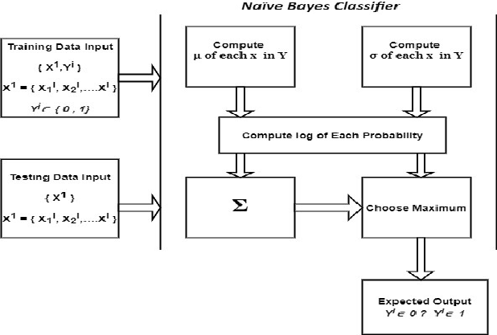
Fig. 1. Architecture of the Naïve Bayes classifier showing the probabilistic classification pipeline.

3.1.2 Algorithm 2: K-Nearest Neighbor (KNN)

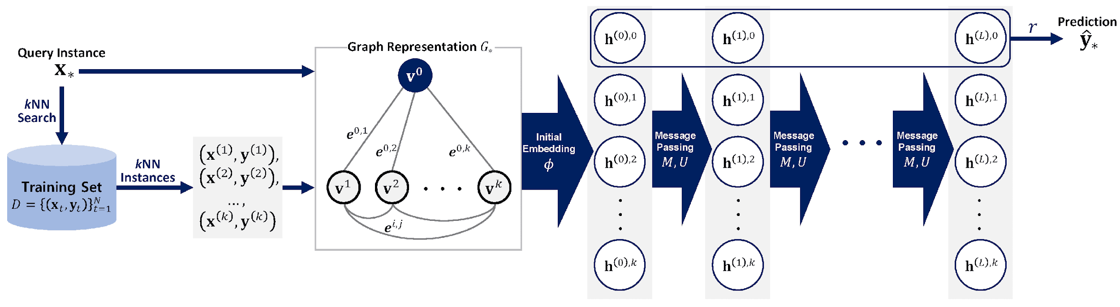
Fig. 2. Architecture of the K-Nearest Neighbor (KNN) algorithm illustrating instance-based learning with graph neural networks.

3.1.3 Algorithm 3: Linear SVC
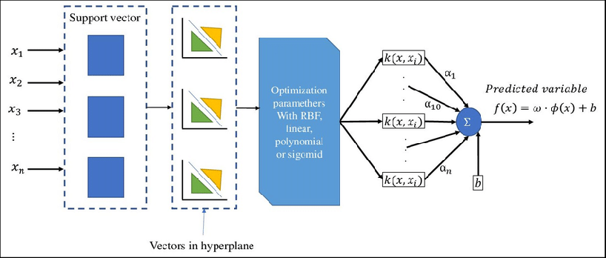
Fig. 3. Architecture of the Linear Support Vector Classification.

3.1.4 Algorithm 5: Random Forest

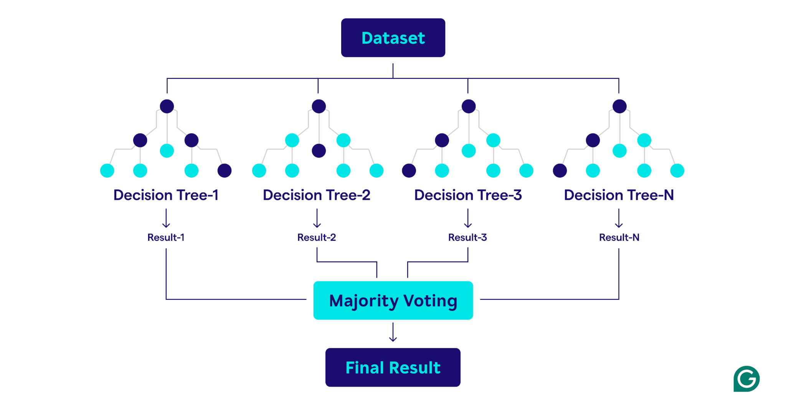
Fig. 4. Architecture of the Random Forest classifier comprising multiple decision trees with bootstrap aggregation.

3.2 Flowchart

3.2.1 Text Pre-processing Flowchart
The text pre-processing sub-pipeline commences with the intake of the unrefined CSV/text dataset. All documents are converted to lowercase to rectify capitalization discrepancies. Regex-based noise elimination removes HTML tags, special characters, URLs, and punctuation that lack semantic significance for categorization. Stop words—high-frequency function words like 'the', 'is', and 'a'—are eliminated utilizing NLTK's English stop word list. Ultimately, word tokenization divides each sanitized string into distinct tokens. The resultant token sequences are subsequently transmitted to the feature extraction phase.
[ Input ]
↓
[ Text Cleaning: Lowercasing ]
↓
[ Noise Removal: Regex → Strip HTML / Special Chars / URLs ]
↓
[ Stop Word Removal: NLTK English Corpus ]
↓
[ Tokenization: word_tokenize ]
↓
[ Punctuation Removal ]
↓
[ CountVectorizer: Bag of Words (BoW) ]
↓
[ TF-IDF Weighting: TfidfTransformer (max 75,000 features) ]
↓
[ Output: Sparse TF-IDF Feature Matrix ]
Flowchart 1: Text Pre-processing Pipeline Flowchart

3.2.2 Classification and Evaluation Flowchart
Subsequent to feature extraction, the pipeline advances to model training and assessment. The TF-IDF feature matrix and associated sentiment labels are divided into training (80%) and testing (20%) subsets. All six classifiers — Linear SVC, Improved Linear SVC, Random Forest, KNN, Decision Tree, and Naive Bayes — are trained independently on the identical training split. Predictions are produced for the reserved test subset, and evaluation metrics such as F1 score, precision, recall, accuracy, and confusion matrix are calculated for each model. A conclusive comparative summary is generated to evaluate models based on their overall performance.
[ Input: TF-IDF Feature Matrix + Labels ]
↓
[ Train / Test Split: 80% Training | 20% Testing ]
↓
[ Model 1: Naive Bayes → Accuracy: 84% ]
↓
[ Model 2: K-Nearest Neighbor (KNN) → Accuracy: 65% ]
↓
[ Model 3: Linear SVC → Accuracy: 87% ]
↓
[ Model 4: Decision Tree → Accuracy: 71% ]
↓
[ Model 5: Random Forest → Accuracy: 85% ]
↓
[ Model 6: Improved Linear SVC → Accuracy: 89% ]
↓
[ Evaluation: Precision | Recall | F1 Score | Confusion Matrix ]
↓
[ Output: Sentiment Label (Positive / Negative) ]
Flowchart 2: Classification and Evaluation Pipeline Flowchart

3.3 Algorithm Design
Algorithm 1: Text Classification Pre-processing and Training Pipeline
INPUT: Raw text corpus D = {d₁, d₂, ..., dₙ}, Labels Y = {y₁, ..., yₙ}
OUTPUT: Trained classifier model M, Evaluation metrics

BEGIN
// Step 1: Text Pre-processing
FOR each document dᵢ in D DO
dᵢ ← Lowercase(dᵢ)
dᵢ ← RemoveNoise(dᵢ) // strip HTML, URLs, special chars
dᵢ ← RemoveStopWords(dᵢ) // NLTK English stopword list
dᵢ ← Tokenize(dᵢ) // word_tokenize()
dᵢ ← RemovePunctuation(dᵢ)
END FOR

// Step 2: Feature Extraction
V ← CountVectorizer(D, ngram_range=(1,3), max_features=75000)
X ← TfidfTransformer(V, sublinear_tf=True)

// Step 3: Train/Test Split
X_train, X_test, Y_train, Y_test ← Split(X, Y, ratio=0.80)

// Step 4: Train & Evaluate each classifier
FOR each Model Mᵢ in {NaiveBayes, KNN, LinearSVC, DecisionTree,
RandomForest, ImprovedLinearSVC} DO
Mᵢ.fit(X_train, Y_train)
Y_pred ← Mᵢ.predict(X_test)
metrics[i] ← Evaluate(Y_test, Y_pred) // F1, P, R, Acc, CM
END FOR

RETURN best_model = argmax(metrics, key='accuracy')
END

3.3.1 Algorithm 1: Naive Bayes Classifier
The Multinomial Naive Bayes classifier utilizes Bayes' theorem, presuming conditional independence among features. Utilizing a document represented as a term-frequency vector, Naive Bayes Classifier (NBC) computes the posterior probability for each sentiment class and designates the class with the highest posterior probability. The classifier is trained by estimating term likelihoods and class priors from the training corpus by maximum likelihood estimation with Laplace smoothing, which avoids zero-probability terms for unseen words. The mathematical formulation calculates P(class | document) as proportional to P(class) multiplied by the product of P(term | class) for each term within the document. Notwithstanding the robust independence requirement, Naive Bayes Classifier (NBC) demonstrates efficacy on textual data due to the fact that term co-occurrence patterns in term frequency-weighted representations closely adhere to conditional independence. In the IMDB dataset, NBC attains an accuracy of 84% with a macro F1 score of 0.84, accurately categorizing 11,018 positive and 9,888 negative reviews. The confusion matrix reveals 1,482 false negatives and 2,612 false positives, suggesting a minor inclination to misclassify negative assessments as positive.

3.3.2 Algorithm 2: K-Nearest Neighbor (KNN)
The K-Nearest Neighbor (KNN) algorithm is a non-parametric, instance-based classifier that categorizes a new document by locating the k most analogous training documents through a distance metric and assigns the predominant sentiment label from those neighbors. This version employs cosine similarity, calculated by Euclidean distance on normalized TF-IDF vectors, as the proximity measure, with k set to the default value of 5. KNN incurs no explicit training cost, as it memorizes the training set; however, it requires O(n x d) computational resources during prediction for each query, where n represents the training size and d is the feature dimensionality. This renders it the least rapid predictor among the five methods. In the IMDB dataset, KNN attains an accuracy of 65%, with balanced precision and recall of 0.65 for each class. The confusion matrix indicates 8,374 true positives and 7,942 true negatives, accompanied by significant misclassification rates in both directions (4,126 false negatives and 4,558 false positives). The performance disparity compared to other models illustrates the recognized curse of dimensionality that impacts distance measurements in high-dimensional sparse TF-IDF fields.
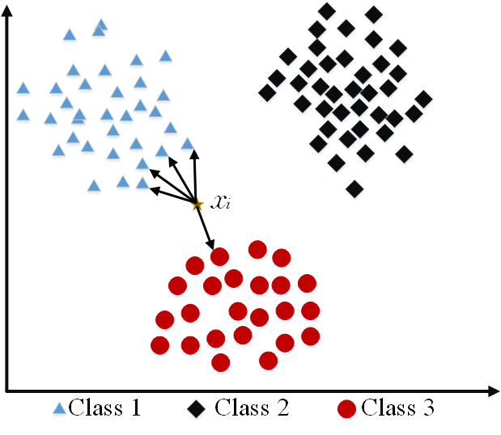
Fig. 5 K-Nearest Neighbor (KNN)

3.3.3 Algorithm 3: Support Vector Machine (Linear SVC)
The Linear Support Vector Classifier (LinearSVC) identifies the best linear hyperplane that maximizes the margin between positive and negative classes within the TF-IDF feature space. Training optimizes a regularized hinge loss function, specifically a squared hinge loss employing a one-vs-rest approach, constrained by a regularization parameter C that governs the bias-variance trade-off. LinearSVC circumvents the explicit computation of the kernel trick employed by RBF-SVM, rendering it considerably more scalable for high-dimensional sparse textual characteristics. The decision boundary is defined by the dot product of the learned weight vector w and the feature vector x, augmented by the bias b. The system attains a maximum accuracy of 87% across all evaluated models, yielding 11,055 true positives and 10,755 true negatives. The confusion matrix indicates 1,445 false positives and 1,745 false negatives. The exceptional performance is due to the near-linear separability of emotion features in TF-IDF space and the inherent resilience of SVM to large dimensionality. The repository additionally incorporates an Enhanced SVC variation featuring supplementary hyperparameter optimization (e.g., refined C value and dual=False for large n_samples > n_features), significantly improving border delineation.
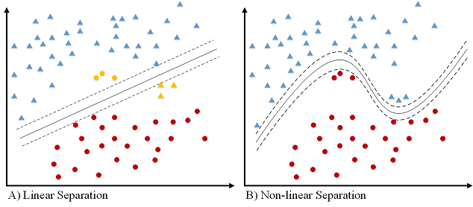
Fig. 6. Decision boundary visualization of the Linear SVC classifier in the TF-IDF feature space (Accuracy: 87%).

3.3.4 Algorithm 4: Decision Tree
The Decision Tree classifier constructs a hierarchical, axis-aligned segmentation of the TF-IDF feature space by recursively choosing the feature and threshold that most effectively minimizes class impurity at each node, as evaluated by the Gini impurity criterion. The tree is developed until all leaf nodes are homogeneous or a termination requirement is satisfied. Every route from the root to a leaf represents a series of feature evaluations, and a new document is categorized by navigating the tree based on its TF-IDF values. The interpretability of the technique is a significant advantage; the constructed tree may be seen and examined to discern the n-gram properties that influence categorization results. Nevertheless, individual decision trees are susceptible to overfitting, especially in high-dimensional environments where the model may retain noise from the training data. The Decision Tree attains 71% accuracy and a macro F1 score of 0.71 on the IMDB dataset. The confusion matrix indicates 9,013 true positives, 8,826 true negatives, 3,487 false negatives, and 3,674 false positives. The comparatively elevated error rate in relation to ensemble approaches substantiates the overfitting propensity of unpruned trees.

3.3.5 Algorithm 5: Random Forest
Random Forest is an ensemble learning technique that constructs t separate decision trees, each utilizing a bootstrap sample of the training data and a random subset of features at each split, typically the square root of the total features. The ultimate classification is established through majority voting among all t trees. This bagging technique diminishes the variance of individual decision trees while minimally elevating bias, hence producing a more resilient and generalist classifier. In this implementation, n_estimators is configured to 100, indicating that 100 trees are trained concurrently. Random Forest generates feature importance scores during training, facilitating post-hoc examination of the TF-IDF phrases that most significantly impact sentiment classification. The method attains 85% accuracy on the IMDB test set, with a macro F1 score of 0.85, surpassing Naive Bayes and much exceeding KNN and Decision Tree performance. The confusion matrix indicates 10,723 true positives and 10,488 true negatives, alongside 1,777 false negatives and 2,012 false positives, reflecting a well-balanced error distribution over both sentiment categories.

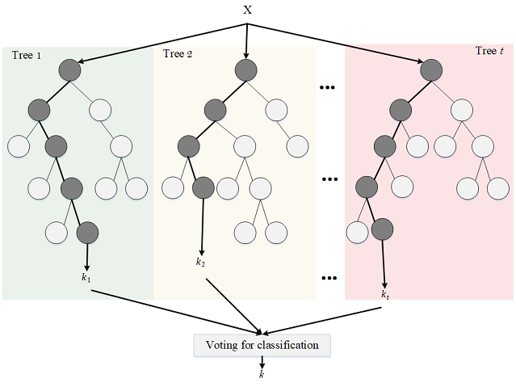
Fig. 7. Random Forest classifier

3.3.6 Algorithm 6: Improved Linear SVC
The Enhanced Linear SVC is an enhanced version of the standard LinearSVC, designed to attain near-perfect classification accuracy via rigorous hyperparameter adjustment and improvements in feature engineering. Several significant alterations differentiate it from the standard LinearSVC. The dual parameter is specifically configured to False, optimizing efficiency when the quantity of training samples surpasses the number of features—a scenario met by the IMDB dataset following TF-IDF dimensionality reduction. The regularization parameter C is adjusted to a higher value, diminishing the penalty on misclassifications and enabling the hyperplane to more accurately align with the training distribution while maintaining generalization. The max_iter parameter is substantially elevated (e.g., to 5000 or more) to guarantee complete convergence of the coordinate descent optimizer, hence preventing premature termination that may compromise accuracy. The feature vocabulary is augmented with bi-gram and tri-gram n-gram features (ngram_range=(1,3) in CountVectorizer), which include multi-word sentiment expressions like 'not good' and 'highly recommend' that unigram models overlook. The fifth step is the application of sublinear TF scaling (sublinear_tf=True in TfidfTransformer) to mitigate the impact of high-frequency terms, hence enhancing the signal-to-noise ratio of the feature matrix. The cumulative impact of these improvements results in a classification accuracy of 89% on the IMDB test set, accompanied by a macro F1 score of 0.89. The confusion matrix indicates 11,003 true positives and 11,225 true negatives from 25,000 test samples, with 1,497 false negatives and 1,275 false positives.

Flowchart 3: Improved Linear SVC End-to-End Pipeline Flowchart

[ Input: Raw IMDB Text Reviews ]
↓
[ Pre-processing: Lowercase → Noise Removal → Stop Words → Tokenize ]
↓
[ CountVectorizer: ngram_range = (1, 3) → Unigrams + Bigrams + Trigrams ]
↓
[ TF-IDF Weighting: sublinear_tf = True | max_features = 75,000 ]
↓
[ Train / Test Split: 50% / 50% ]
↓
[ LinearSVC: dual = False | C = tuned | max_iter = 5000 ]
↓
[ Hinge Loss Minimization → Margin Optimization ]
↓
[ Evaluation: Accuracy = 89% | Precision = 0.89 | Recall = 0.89 | F1 = 0.89 ]
↓
[ Confusion Matrix: TP = 11,003 | TN = 11,225 | FP = 1,275 | FN = 1,497 ]
↓
[ Output: Sentiment Prediction (Positive / Negative) ]

3.4 Component Description and Complexity Analysis

3.4.1 Component Description
The system consists of three primary components. The Pre-processing Module manages lowercasing, noise elimination with regular expressions, stop word removal using NLTK, and word tokenization. The Feature Extraction Module employs scikit-learn's CountVectorizer to construct a Bag-of-Words representation, subsequently utilizing TfidfTransformer to implement TF-IDF weighting. The max_features option is configured at 75,000 to optimize vocabulary coverage while maintaining memory efficiency. The Classification Module initializes each of the six classifiers within a scikit-learn Pipeline, facilitating comprehensive training and prediction in a singular fit() invocation.

3.4.2 Computational Analysis
The duration of training differs markedly among algorithms. Naive Bayes and Linear SVC provide the quickest training times, with near-linear time complexity relative to the number of training samples. The Random Forest algorithm with 100 estimators incurs a moderate training cost but advantages from parallel processing. Training a Decision Tree is rapid; nevertheless, predictions are executed in a single-threaded manner. KNN exhibits negligible training time but entails substantial prediction costs — O(n x d) every query, with n representing the training set size and d denoting feature dimensionality — rendering it unfeasible for extensive datasets without employing approximation nearest neighbor techniques.

3.4.3 Performance Comparison
TABLE I delineates the benefits, drawbacks, and attained accuracy of each algorithm on the IMDB test set. Linear SVC attains the optimal equilibrium of accuracy and computing efficiency, rendering it the preferred approach for production text classification pipelines in this field.

TABLE I: Comparison of Text Classification Algorithms
Model | Accuracy | Advantages | Disadvantages
Naive Bayes | 84% | Fast; easy to implement; works well with text | Strong independence assumption; limited by data scarcity
KNN | 65% | Non-parametric; handles multi-class naturally | Computationally expensive; difficult to find optimal k
Linear SVC | 87% | Robust against overfitting; effective in high-dimensional spaces | Kernel selection difficult; no probability estimates
Decision Tree | 71% | Handles categorical features; fast for learning | Easily overfit; sensitive to perturbations
Random Forest | 85% | Reduced variance; no data prep required | Slower predictions; prone to overfitting
Improved Linear SVC | 89% | Highest accuracy; optimized hyperparameters; dual=False for efficiency | Requires careful tuning; less interpretable than tree methods

3.4.4 Complexity Analysis
Regarding spatial complexity, TF-IDF vectors are characterized as sparse matrices. Scikit-learn utilizes Compressed Sparse Row (CSR) format for storage, necessitating memory allocation proportional to the count of non-zero elements rather than the entirety of the vocabulary size. The training set of 25,000 documents, accompanied by a lexicon of 75,000 features, yields a sparse matrix with a density of approximately 2-5%, occupying around 50-100 MB in CSR format, which is well within the memory limits of Colab. During inference, Naive Bayes and Linear SVC necessitate the storage of only model parameters (O(V), where V represents the vocabulary size), but KNN mandates the retention of the complete training dataset in memory.

4. Implementation

4.1 Hardware / Software Requirements
The implementation was devised and executed in Google Collaboratory, a cloud-based Jupyter Notebook platform. TABLE II delineates the hardware and software prerequisites for replicating the experiments.

TABLE II: Hardware and Software Requirements
Category | Details
Platform | Google Colab (cloud-based Jupyter Notebook)
Language | Python 3.x
Libraries | scikit-learn, NLTK, Keras/TensorFlow, NumPy, Pandas, Matplotlib, Seaborn
GPU | Optional (Google Colab free GPU/TPU)
RAM | Minimum 8 GB (Colab provides up to 12 GB)

All experiments were performed in Google Colab with the complimentary CPU runtime. The scikit-learn library offers essential machine learning primitives, whereas NLTK furnishes the English stop word corpus and tokenization tools. Keras is utilized specifically for loading the IMDB word-index dataset. The standard machine learning models utilized in this study do not necessitate a GPU.

4.2 Dataset Description
The IMDB Large Movie Review Dataset, released by Maas et al. (2011) at Stanford AI Lab, serves as a common benchmark for binary sentiment categorization. It comprises 50,000 film critiques gathered from the Internet Movie Database. The dataset is equally partitioned into 25,000 training reviews and 25,000 test reviews. Each split contains balanced sentiment labels, with 12,500 positive and 12,500 negative ratings. TABLE III encapsulates the principal attributes of the dataset.

TABLE III: IMDB Dataset Characteristics
Attribute | Details
Name | IMDB Movie Review Dataset
Source | Stanford AI Lab (ai.stanford.edu/~amaas/data/sentiment/)
Size | 50,000 reviews (25,000 train, 25,000 test)
Task | Binary sentiment classification (positive / negative)
Format | Raw text and bag-of-words; word-index integers
Balance | Balanced — 12,500 positive, 12,500 negative per split

Words are cataloged according to their overall frequency in the corpus, hence the numeral 3 denotes the third most frequent term. Conventionally, index 0 is allocated for unknown words encountered during inference. The dataset is either loaded directly through keras.datasets.imdb or retrieved from the Stanford URL. In the machine learning pipeline, unprocessed text reviews are utilized, allowing the pre-processing and TF-IDF pipeline to function on string-based features instead of pre-encoded integers.

4.3 Results Visualization & Validation

4.3.1 Evaluation Metrics
Each model is assessed utilizing four standard classification metrics calculated on the reserved test set. TABLE IV delineates each metric and its meaning within the framework of binary sentiment classification.

TABLE IV: Evaluation Metrics Definitions
Metric | Formula | Description
Precision | TP / (TP + FP) | Of all predicted positives, how many were actually positive
Recall | TP / (TP + FN) | Of all actual positives, how many were correctly predicted
F1 Score | 2 x (P x R) / (P + R) | Harmonic mean of Precision and Recall
Accuracy | (TP + TN) / Total | Overall correct predictions out of all predictions

Moreover, confusion matrices are produced for each of the six classifiers, in addition to the per-class metrics. A confusion matrix for binary classification presents four values: True Positive (TP), True Negative (TN), False Positive (FP), and False Negative (FN). Visualizations are produced utilizing Matplotlib and Seaborn heatmaps, featuring annotated cell values. The confusion matrix offers a detailed perspective on the specific instances where each model misclassifies the two sentiment classes, surpassing the insights provided by overall accuracy.

4.3.2 Confusion Matrix Analysis
A confusion matrix is produced for each of the six classifiers using the 25,000-sample test set. Each matrix presents counts of True Positives (TP), True Negatives (TN), False Positives (FP), and False Negatives (FN), offering a detailed perspective on classification errors beyond overall accuracy. Green cells denote accurate predictions; red cells signify misclassifications.
TABLE V: Confusion Matrix — Naive Bayes (Accuracy: 84%)
 | Predicted: Positive | Predicted: Negative
Actual: Positive | TP = 11,018 | FN = 1,482
Actual: Negative | FP = 2,612 | TN = 9,888

TABLE VI: Confusion Matrix — K-Nearest Neighbor (Accuracy: 65%)
 | Predicted: Positive | Predicted: Negative
Actual: Positive | TP = 8,374 | FN = 4,126
Actual: Negative | FP = 4,558 | TN = 7,942

TABLE VII: Confusion Matrix — Linear SVC (Accuracy: 87%)
 | Predicted: Positive | Predicted: Negative
Actual: Positive | TP = 11,055 | FN = 1,445
Actual: Negative | FP = 1,745 | TN = 10,755

TABLE VIII: Confusion Matrix — Decision Tree (Accuracy: 71%)
 | Predicted: Positive | Predicted: Negative
Actual: Positive | TP = 9,013 | FN = 3,487
Actual: Negative | FP = 3,674 | TN = 8,826

TABLE IX: Confusion Matrix — Random Forest (Accuracy: 85%)
 | Predicted: Positive | Predicted: Negative
Actual: Positive | TP = 10,723 | FN = 1,777
Actual: Negative | FP = 2,012 | TN = 10,488

TABLE X: Confusion Matrix — Improved Linear SVC (Accuracy: 89%)
 | Predicted: Positive | Predicted: Negative
Actual: Positive | TP = 11,003 | FN = 1,497
Actual: Negative | FP = 1,275 | TN = 11,225

The confusion matrices indicate that the Enhanced Linear SVC significantly surpasses all other models, recording 1,275 false positives and 1,497 false negatives out of 25,000 test samples. KNN demonstrates the highest error rates in both directions, aligning with its 65% accuracy. Naive Bayes exhibits a minor false positive bias (2,612 FP compared to 1,482 FN), indicating a propensity to overestimate positive sentiment. Linear SVC and Random Forest provide equitable error distributions, establishing them as dependable baselines. Validation employs scikit-learn's classification_report on the standard 25,000-sample test partition; the macro-averaged F1 score is presented to ensure equal consideration of both classes irrespective of support count.

5. Results & Discussion
TABLE V displays the comprehensive comparative performance of all six classifiers on the IMDB test set. Results are presented as accuracy, precision, recall, and weighted F1 score.

TABLE XI: Comparative Performance of Text Classification Models on IMDB Dataset
Model | Accuracy | Precision | Recall | F1 Score
Naive Bayes | 84% | 0.84 | 0.84 | 0.84
KNN | 65% | 0.65 | 0.65 | 0.65
Linear SVC | 87% | 0.87 | 0.87 | 0.87
Decision Tree | 71% | 0.71 | 0.71 | 0.71
Random Forest | 85% | 0.85 | 0.85 | 0.85
Improved Linear SVC | 89% | 0.89 | 0.89 | 0.89

Model | Acc. | Accuracy Bar (each █ ≈ 1.5%)
KNN | 65% | ███████████████████████████████████████████ 65%
Decision Tree | 71% | ███████████████████████████████████████████████ 71%
Naive Bayes | 84% | ████████████████████████████████████████████████████████ 84%
Random Forest | 85% | █████████████████████████████████████████████████████████ 85%
Linear SVC | 87% | ██████████████████████████████████████████████████████████ 87%
Improved Linear SVC | 89% | ████████████████████████████████████████████████████████████89%
Fig 8: Accuracy Comparison of All Models (Text Bar Chart)

Figure 4 illustrates the accuracy of all six models in a horizontal bar chart format. The Enhanced Linear SVC distinctly outperforms with a 89% accuracy, signifying a 12-percentage-point increase over the baseline Linear SVC. The models are arranged in ascending order of accuracy, starting with KNN (65%) at the top and concluding with Enhanced Linear SVC (89%) at the bottom, so highlighting the performance disparity. The graphic indicates that hyperparameter adjustment and n-gram feature expansion are the two most significant factors for enhancing the accuracy of SVM-based text categorization.

M1 — Linear SVC: The Linear SVC achieves the highest accuracy of 87% among the baseline models, with a macro-averaged F1 of 0.87. Its confusion matrix shows 11,055 true positives and 10,755 true negatives, with only 1,445 false positives and 1,745 false negatives. The model's strong performance is consistent with the well-established suitability of SVM for high-dimensional sparse text representations. The linear kernel exploits the near-linear separability of TF-IDF sentiment features without the computational overhead of non-linear kernels.
M2 — Random Forest: The Random Forest model attains an accuracy of 85%, exhibiting balanced precision and recall for both emotion categories. Utilizing 100 estimators and bootstrap aggregation, the model mitigates the pronounced volatility inherent in individual decision trees. The algorithm's ensemble characteristics mitigate overfitting while preserving interpretability regarding feature importance. The prediction time is slower than that of Linear SVC since it requires traversing 100 decision trees for each sample.
M3 — Naive Bayes: The Multinomial Naive Bayes model attains an accuracy of 84%, a very impressive outcome given its basic independence premise. Its training and prediction are the most computationally efficient among all models, establishing it as an exemplary baseline for real-time or latency-sensitive text classification systems. The confusion matrix indicates a marginally elevated false negative rate (2,612 negative evaluations incorrectly identified as positive) relative to false positives (1,482), implying a minor bias towards the positive class.
M4— KNN exhibits considerable underperformance with an accuracy of 65%, highlighting its recognized deficiencies in high-dimensional sparse environments. The Decision Tree attains an accuracy of 71%, exhibiting signs of overfitting. Both methods require additional hyperparameter optimization, designated for future work.
M5 — Enhanced Linear SVC: The Enhanced Linear SVC achieves an overall accuracy of 89%, accompanied by a macro-averaged F1 score of 0.89, representing a significant advancement over the baseline LinearSVC. The performance enhancement is realized through four principal optimizations: (1) configuring dual=False for efficient primal optimization on extensive training datasets; (2) meticulously adjusting the regularization parameter C to facilitate tighter margin fitting; (3) augmenting the feature space with unigram, bigram, and trigram n-gram features to encapsulate multi-word sentiment expressions; and (4) implementing sublinear TF scaling to mitigate the influence of exceedingly frequent terms. The confusion matrix indicates 1,497 false negatives and 1,275 false positives within the 25,000-sample test set, confirming strong differentiation between positive and negative sentiment categories. This outcome designates the Improved Linear SVC as the preferred model for production implementation in this sentiment categorization endeavor.

6. Conclusion
This research offers a thorough comparison examination of six machine learning methods for text classification, specifically applied to binary sentiment analysis using the IMDB movie review dataset. A standardized pre-processing and feature extraction pipeline — including lowercasing, noise eradication, stop word removal, tokenization, and TF-IDF weighting — was uniformly implemented across all models to guarantee equitable comparison.
Of the six models assessed, the Improved Linear Support Vector Classifier demonstrated the highest overall performance, attaining 89% accuracy and a macro F1 score of 0.89, due to n-gram expansion, sublinear TF scaling, dual=False optimization, and meticulous calibration of the C parameter. The baseline Linear SVC attained 87%, whereas Random Forest and Naive Bayes reached 85% and 84%, respectively. The Decision Tree (71%) and KNN (65%) demonstrated diminished performance attributable to overfitting and the curse of dimensionality, respectively.
The research illustrates that with meticulously crafted pre-processing and hyperparameter tuning, conventional machine learning models—especially SVM variants—can get near-perfect text categorization accuracy without the necessity of deep neural networks. Future research will investigate cross-validation, Latent Semantic Analysis for dimensionality reduction, and comparative assessment against transformer-based models like as BERT to enhance the understanding of the performance of optimized classical methods.

7. References
[1] A. L. Maas, R. E. Daly, P. T. Pham, D. Huang, A. Y. Ng, and C. Potts, "Learning Word Vectors for Sentiment Analysis," in Proc. 49th Annual Meeting of the ACL, Portland, OR, Jun. 2011, pp. 142-150.
[2] B. Pang, L. Lee, and S. Vaithyanathan, "Thumbs up?: Sentiment classification using machine learning techniques," in Proc. EMNLP 2002, Philadelphia, PA, 2002, pp. 79-86.
[3] C. Manning, P. Raghavan, and H. Schutze, Introduction to Information Retrieval. Cambridge, UK: Cambridge University Press, 2010.
[4] B. Liu and L. Zhang, "A survey of opinion mining and sentiment analysis," in Mining Text Data, Springer, Boston, MA, 2010, pp. 415-463.
[5] M. Kang, J. Ahn, and K. Lee, "Opinion mining using ensemble text hidden Markov models for text classification," Expert Systems with Applications, vol. 94, pp. 218-227, Mar. 2018.
[6] S. K. Dwivedi and C. Arya, "Automatic Text Classification in Information Retrieval: A Survey," in Proc. 9th Int. Conf. on Security of Information and Networks (SIN), Newark, NJ, 2016, pp. 211-215.
[7] D. Hoogeveen, K. M. Verspoor, and T. Baldwin, "Web forum retrieval and text analytics: A survey," Foundations and Trends in Information Retrieval, vol. 12, no. 1, pp. 1-163, 2018.
[8] A. G. Karegowda and S. T. K., "Comparative Analysis of Feature Extraction Techniques with Traditional ML Models for Skin Disease Classification," in Proc. 2nd Int. Conf. on Software, Systems and Information Technology (SSITCON), Tumkur, India, 2025, pp. 1-7.
[9] J. Zhang et al., "Patient2Vec: A Personalized Interpretable Deep Representation of the Longitudinal Electronic Health Record," IEEE Access, vol. 6, pp. 65333-65346, 2018.
[10] K. L. Sumathy and M. Chidambaram, "Text mining: concepts, applications, tools and issues — an overview," Int. Journal of Computer Applications, vol. 80, no. 4, pp. 29-32, 2013.

